

**SSE 4300**

**SOFTWARE PROJECT MANAGEMENT**

**REPORT FOR RISK MANAGEMENT**

**GROUP**

**WOLF LG**

|  |  |  |
| --- | --- | --- |
| NO | NAME | MATRIC |
| 1 | NUR ADAWIYAH FAKHIRAH BINTI MOHD AZAHADI (TASK LEADER) | 187111 |
| 2 | NOOR ALIANA BINTI MOHD ALIAS | 187294 |
| 3 | SITI NURKHADIJAH BINTI SULLAHAJI | 186906 |
| 4 | YU WEIHAO | 191358 |

**LECTURER’S NAME**

**DR. NORHAYATI BINTI MOHD ALI**

**CONTENTS**

1.0 INTRODUCTION

2.0 SCOPE

3.0 PURPOSE

4.0 RISK MANAGEMENT ACTIVITIES

4.1 RISK IDENTIFICATION

4.2 RISK ANALYSIS

4.3 RISK PLANNING

4.4 RISK MONITORING

5.0 SUPPORTING TOOL

6.0 CONCLUSION

7.0 CONTINUITY

### **1.0 INTRODUCTION**

### In recent years, software development technologies and tools have made great progress, but software project development timeouts, overspending, and even failing to meet user needs and not actually getting used are still abound. Software project risk management is a software project. Important content of management The risk in software development refers to the damage or loss that may occur in the software development process and the software product itself. Risk concerns the future, which means that risk involves the uncertainty of choice and choice itself, and the software development process and software products are faced with a variety of decision-making options. Risk is the state between certainty and uncertainty, and is the state between ignorance and complete knowledge. On the other hand, risk will involve changes in factors such as thoughts, ideas, behaviors, and locations. When conducting software project risk management, identify risks, assess their probability of occurrence and impact, and then establish a plan to manage risk. The main goal of risk management is to prevent risks. The goal of this product is to correctly predict and see possible risks and to meet customer needs.

### 2.0 SCOPE

### 1) Business risk Product size risk, business risk, project demand risk, customer characteristic risk, process risk

### 2) Technical risks Technical situation risk, development environmental risk

### 3) Organizational risk Number of personnel and their experience risk

### 

### 

### **3.0 PURPOSE**

### 1）The survival and development of enterprises and organizations and members. The basic goal of risk management is that companies and organizations can survive in the face of risks and accidents. Risk management programs should enable companies and organizations to continue to grow in the face of losses. Achieving this goal means that through the various efforts of risk management, economic units, families, individuals and even society can be protected from disaster losses. Therefore, maintaining the survival of organizations and members is the primary goal of risk management after loss.

### 2) Ensure that all activities of the organization resume normal operation. The emergence of risk accidents will bring people different degrees of loss and harm, which will affect or break the normal state of the organization and people's normal life order, and may even cause the organization to fall into paralysis. Implementing risk management can help organizations quickly return to normal operations and help people move from disorder to order as quickly as possible. This goal requires companies to choose the right balance point in loss control insurance and other risk management tools to achieve effective risk management performance.

### 3）Realize the stable income of enterprises and organizations as soon as possible. Enterprises and economic units, after facing risk accidents, rely on risk management. On the one hand, they can restore production and management in time through economic compensation, and ensure the stability of business operations to the greatest extent possible; on the other hand, they can provide other assistance to enterprises. So that it will return to the pre-loss level as soon as possible, and prompt enterprises to achieve sustainable growth plans as soon as possible.

### 4) Reduce anxiety and fear and provide security. The occurrence of a risk accident will not only lead to material damage and personal injury, but also bring serious anxiety and fear to people. Implementing risk management can reduce people's psychological worries as much as possible, enhance security, create a relaxed production and living environment, or reduce psychological pressure caused by accidents. Therefore, it is also an important goal of risk management.

### 5）Maximize the value of the business or organization by minimizing risk costs. In general, the value of the company is reduced due to the existence of risk, which constitutes the risk cost. Pure risk costs include: i. expected loss costs

### ii. loss control costs

### iii. loss financing costs

### Iv. internal risk control costs

### Through comprehensive systematic risk management, the risk cost of the enterprise can be reduced, thereby reducing the occurrence of disaster losses and the cash outflow of the enterprise, and maximizing the value of the enterprise by minimizing the risk cost.

### 

### **4.RISK MANAGEMENT ACTIVITIES**

4.1) **Risk Identification**

|  |  |
| --- | --- |
| Risk Type | Possible Risk |
| Technology | * Have to catch up with the up to date technology due to the increasing demand * Lack of knowledge in the software that going to use in the project * Database used in the software cannot process as expectations |
| People | * Impossible to hire staff that expert with the skills required * Need training for the staff that are not expert in skills required * The staff who is an expert in the system might be unavailable at the critical times |
| Organizational | * Financial problems might affect the project * Organizational is restructured so that different management are responsible for the project |
| Tools | * Software tools cannot work together in an integrated way * Cannot connect the system with the server |
| Requirements | * Changes in the requirements that require major rework * User fail to understand the impact requirements changes |
| Estimation | * The time for the project to finish is underestimated * The size of the software is underestimated * The cost estimation increasing due to the extent of the project |

4.2) **Risk Analysis**

|  |  |  |
| --- | --- | --- |
| Risk | Probability | Effects |
| Have to catch up with the up to date technology due to the increasing demand | High | Serius |
| Lack of knowledge in the software that going to use in the project | High | Catastrophic |
| Database used in the software cannot process as expectations | High | Toreable |
| Impossible to hire staff that expert with the skills required | Very High | Catastrophic |
| Need training for the staff that are not expert in skills required | Moderate | Toreable |
| The staff who is an expert in the system might be unavailable at the critical times | Moderate | Toreable |
| Financial problems might affect the project | Very High | Catastrophic |
| Organizational is restructured so that different management are responsible for the project | High | Insignificant |
| Software tools cannot work together in an integrated way | High | Catastrophic |
| Cannot connect the system with the server | Moderate | Toreable |
| Changes in the requirements that require major rework | Very High | Serious |
| User fail to understand the requirements changes | High | Serius |
| The time for the project to finish is underestimated | Very High | Catastrophic |
| The size of the software is underestimated | High | Serius |
| The cost estimation increasing due to the extent of the project | Very High | Catastrophic |

4.3 **Risk Planning**

|  |  |
| --- | --- |
| Risk | Strategy |
| Have to catch up with the up to date technology due to the increasing demand | Investigate and keep up to date with the newest technology used before starting the project. |
| Lack of knowledge in the software that going to use in the project | Prepare a briefing and training for the software that will be used in the project. |
| Database used in the software cannot process as expectations | Investigate the possibility of buying a higher performance database. |
| Staff illness | Reorganize team so there is more overlap of work and people. Therefore understand each other’s jobs. |
| Financial problems might affect the project | Prepare a briefing document for senior management showing how the project is making a very important contribution to the goals of business and presenting reasons why cuts to the project budget will not cost-effective. |
| Organizational is restructured so that different management are responsible for the project | Prepare briefing document for senior management showing how the project is making a very important contribution to the goals of business. |
| Software tools cannot work together in an integrated way | Replace potentially software tools that have higher possibility cannot work together in an integrated way with bought-in software tools of known reliability. |
| Cannot connect the system with the server | Make sure an earlier software installation on the client computer did not leave the computer in a restart pending state, and restarting the computer does not clear the state. |
| Changes in the requirements that require major rework | Derive traceability information to assess requirements change impact; maximize information hiding in the design. |
| User fail to understand the impact of requirements changes | Prepare a briefing explanations to the user about the impact that will happen if they want to change a requirement in the middle of development time. |
| The time for the project to finish is underestimated | investigate buying-in components, investigate the use of a program generator. |
| The size of the software is underestimated | Use a software sizing method that is consistent and repeatable, and regularly re-estimate the size of the product and the associated cost of the project as specs change. |
| The cost estimation increasing due to the extent of the project | Hire an expert at the first place to involve in the project so that the project can be delivered in time. Consistently time tracking and analyse the progress of the project. |

4.4 **Risk Monitoring**

|  |  |
| --- | --- |
| Risk Type | Indicators |
| Technology | Late delivery of support software or hardware and also many reported technology problems. |
| People | Poor staff self-confidence, poor team spirit; high rate of staff replacement. |
| Organizational | Organizational gossip, lack of action by senior management. |
| Tools | Unwillingness by team members to use tools, complaints about the CASE tools, demand for higher-powered workstations |
| Requirements | Many chance request |
| Estimation | Failure to meet agreed schedule, failure to clear reported defects |

### 

### 

### **5.0 SUPPORTING TOOLS**

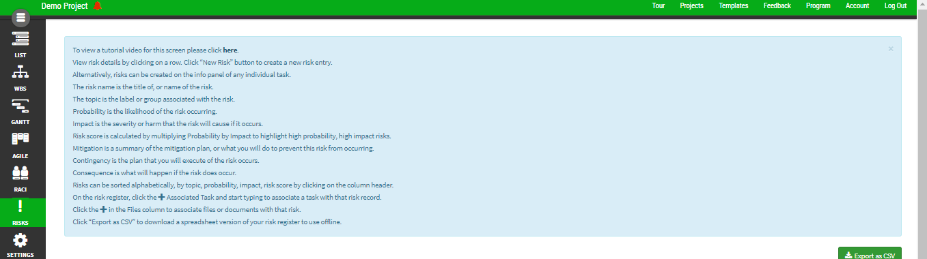

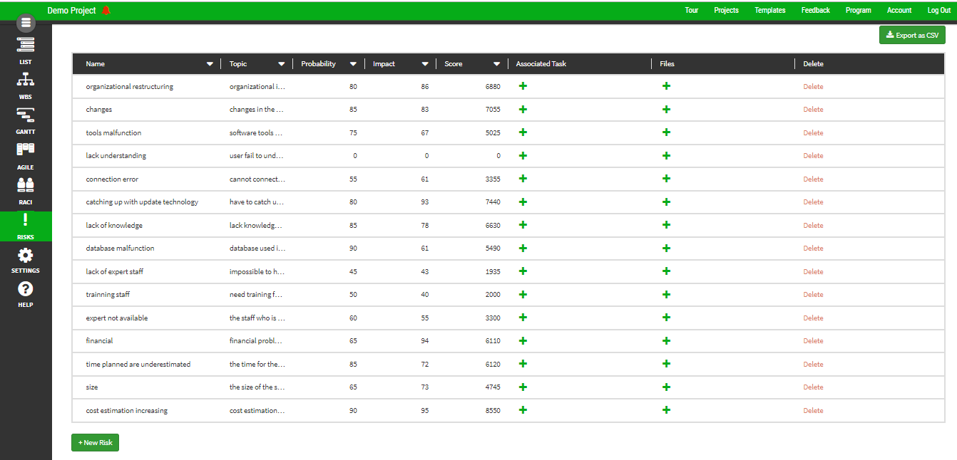

PlanHammer is an open source application available online and can be used to do project management from project planning.This PlanHammer tool calculate risk score when we put probability percentage and impact percentage. So, we can detect which risk is the critical one that needs to solve first. For this project cost estimation increasing is the most critical risk.

### **6.0 CONCLUSION**

There a several risks that have been identified and analysed that will occur during the development time of the project. Besides, the strategies to prevent the risk happen also been identified. Therefore, we hope this project can avoid many risks that have been listed in this report and the project can be delivered on time and cost of the project within the budget given.

**7.0 CONTINUITY**

After this report is finished, the next report is about Software Quality Management Tool. In this report, we will know whether our product is following all the criteria in software quality. Next, will determine which standard that going to use for writing the documentation of the product. Furthermore, reviewing the document is important to ensure that there are no flaws in our product. Lastly, we will measure our product so that we can improve the development process so that the product quality will be increased, thus making the customer happy.